Acceptance Test Procedure

Results (SKYDOC-1180)

For

Skyryse Flight OS LEMA TPX 325

Software Version: 1918900-DEV

|  |  |  |  |  |
| --- | --- | --- | --- | --- |
| LEMA Assembly Part Number | Operator | Condition | Serial Number | Test Start Time |
| LEMA | Hayden | Engineering | 0002 | 6/12/2023 2:54:00 PM |

|  |  |  |
| --- | --- | --- |
| **Summary of Test Results:** | **Fail** | |
|  | | |
| **Requirements** | **Pass/Fail** | |
| **6.1 Visual Examination of the Product** | **Pass** | |
| **6.2 Weight** | **Pass** | |
| **6.3 Bonding** | **Pass** | |
| **6.4 Resistance and Inductance Test (motor and Solenoid)** | **Fail** | **Fail** |
| **6.5 Power ON UUT Checks** | **Pass** | |
| **6.6.1 MCE (MCE1, MCE2, MCE3) Power Up** | **Pass** | |
| **6.6.3 Holding Load Test** | **Fail** | **Fail** |
| **6.6.4 Brake Release** | **Pass** | |
| **6.6.5 N1 and N2 Extend Mechanical Stops and MCE Rigging** | **Fail** | |
| **6.6.6 N1 and N2 Stroke** | **Fail** | |
| **6.6.7 Performance Test – unloaded operation (one channel operation)** | **Fail** | |
| **6.6.8 Performance Test – Loaded Operation** | **Fail** | |
| **6.6.9 Backlash** | **Fail** | |

**Table of Units**

|  |  |
| --- | --- |
| **Unit** | **Abbreviation used** |
| Pounds | lbs. |
| Milliohms | mOhms |
| Ohms | Ohms |
| MilliHertz | mHz |
| Hertz | Hz |
| Inches | in |
| Pounds of force | lbf |
| Ampheres | A |
| Bit values in Hexadecimal | Code |
| Inches per Second | in/s |
| Milliseconds | ms |
| Seconds | seconds |
| Decibel | dB |
| Degrees | deg |
| Tolerance in the range of | +/- |
| Requirements | Reqs. |

**6.1. Visual Examination of the Product**

|  |  |
| --- | --- |
| UUT conforms to the requirements of paragraph 6.1 | Pass |

**6.2 Weight**

|  |  |  |  |
| --- | --- | --- | --- |
| **UUT Weight** | | | |
| **Requirements** | **Results** | | |
| **UUT weight should not exceed** | **Actual Weight** | **Units** | **Pass/Fail** |
| 10 | 9 | lbs. | Pass |

6.3 Bonding

Bonding resistance:

|  |  |  |  |  |  |  |  |
| --- | --- | --- | --- | --- | --- | --- | --- |
| **Bonding Resistance** | | | | | | | |
| **Requirements** | | **Results** | | **Reqs.** | **Results** | | |
|  | **Simplex max allowed** | **Simplex Actual** | **Pass/Fail** | **Duplex max allowed** | **Duplex Actual** | **Pass/Fail** | **Units** |
| Motor End Cap | 10 | 9 | Pass | 12.5 | 12 | Pass | (mOhms) |
| Solenoid housing | 10 | 8 | Pass | 10 | 9 | Pass | (mOhms) |
| Encoder cover | 7.5 | 8 | Failed | 7.5 | 7 | Pass | (mOhms) |
| All Bonding Pass/Fail | | | Fail | | Pass | |  |

**6.4 Resistance and Inductance Test** **(motor and solenoid)**

**Resistances:**

|  |  |  |  |  |  |  |
| --- | --- | --- | --- | --- | --- | --- |
| **Motor and Solenoid Resistances** | | | | | | |
| **Requirements** | | | **Results** | | | |
| Pins | **Expected** | **Tolerance** | **Connector J1** | **Connector J2** | **Connector J3** | **Units** |
| E to F | 0.212 | 0.0212 | 0.121 | 0.212 | 0.212 | (Ohms) |
| F to G | 0.212 | 0.0212 | 0.25 | 0.152 | 0.221 | (Ohms) |
| G to E | 0.212 | 0.0212 | 0.22 | 0.2312 | 0.2313 | (Ohms) |
| A to L | 6.55 | 0.44 | 0.265 | 0.25 | 0.22 | (Ohms) |
| G,F,E,A,L tied together to chassis grounds. Apply 500VDC | 5000000 | 0 | 0.258 | 0.245 | 0.258 | (Ohms) |
| All Resistances Pass/Fail | | | Fail | | |  |

**Inductances:**

|  |  |  |  |  |  |  |
| --- | --- | --- | --- | --- | --- | --- |
| **Motor and Solenoid Inductances** | | | | | | |
| **Requirements** | | | **Results** | | | |
|  | **Expected** | **Tolerance** | **Connector J1** | **Connector J2** | **Connector J3** | **Units** |
| E to F | 0.155 | 0.02325 | 0.155 | 0.1555 | 0.25 | (mHz) |
| F to G | 0.155 | 0.02325 | 0.155 | 0.175 | 0.255 | (mHz) |
| G to E | 0.155 | 0.02325 | 0.152 | 0.256 | 0.152 | (mHz) |
| A to L | 22 | 3.3 | 22 | 24 | 19 | (mHz) |
| All Inductances Pass/Fail | | | Fail | | |  |

**6.5 Power ON UUT Checks**

Confirm all sensors are reporting nominal values and no faults reported

|  |  |  |  |
| --- | --- | --- | --- |
| **Power ON UUT Checks** | | | |
| **Description** | **Results** | | |
| **Sensor** | **Value** | **Units** | **Pass/Fail** |
| Motor 1 | -0.0033 | in | Pass |
| Motor 2 | -0.0016 | in | Pass |
| Motor 3 | 0.0147 | in | Pass |
| M1 | 0.0000 | in | Pass |
| M2 | 0.0000 | in | Pass |
| M3 | 0.0000 | in | Pass |
| Faults 1 | 400 | Code | Pass |
| Faults 2 | 400 | Code | Pass |
| Faults 3 | 400 | Code | Pass |

**6.6 Functional Check Out**

**6.6.1 MCE1, MCE 2, MCE3 Power Up**

|  |  |  |  |  |
| --- | --- | --- | --- | --- |
| **Functional Check Out** | | | | |
| **Requirements** | **Results** | | | |
| **Description** | **Ballnut position** | **Units** | **Pass/Fail** | |
| MCE 1 reports values for Ballnut position and motor current | 0 | in | Ballnut Position | Current |
| Pass | Pass |
| (Simulated) FCC/reports values for M1(QPS) | -0 | in | Pass |  |
| MCE 2 reports values for Ballnut position and motor current | 0 | in | Pass | Pass |
| (Simulated) FCC/reports values for M2(QPS) | -0 | in | Pass |  |
| MCE 3 reports values for Ballnut position and motor current | 0.0012 | in | Pass | Pass |
| (Simulated) FCC/reports values for M3(QPS) | -0 | in | Pass |  |

**6.6.3 Holding Load Test**

**6.6.3.1 Brake OFF, LEMA Output Locked**

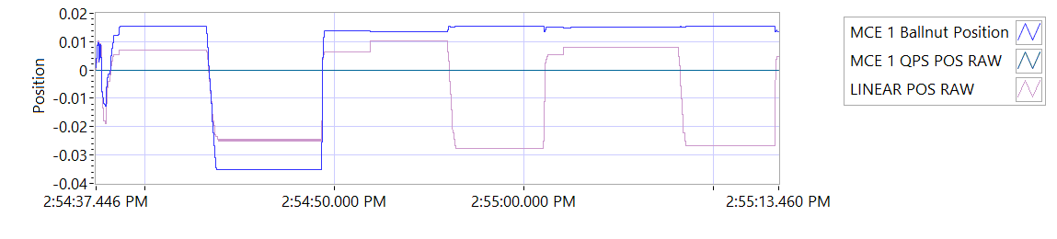

Figure -Hold Brake OFF for MCE 1

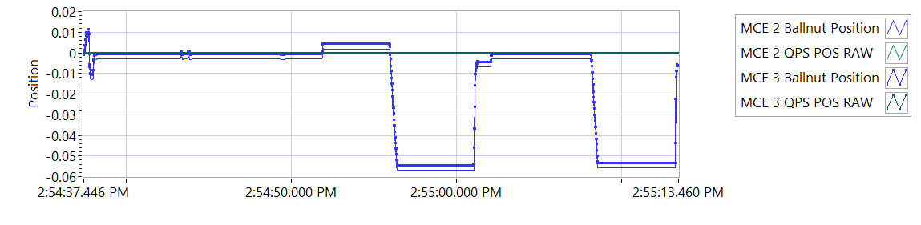

Figure -Hold Brake OFF for MCE 2

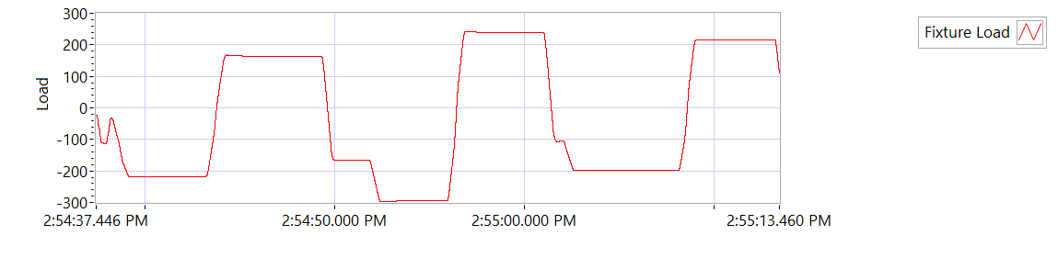

Figure -Hold Brake OFF for MCE 3

|  |  |  |  |  |  |
| --- | --- | --- | --- | --- | --- |
| **Holding Load Test - Brake OFF, LEMA Output Locked** | | | | | |
| **Requirements** | | | **Results** | | |
| **MCE** | **Expected Output Force/Amps** | **Tolerance** | **Actual Output force/Amps** | **Units** | **Output force/Amps, Pass/Fail** |
| MCE 1, 6.6.3.1.1 step d/e– extend 0.4 in, Sustain 12.6 Amps (TBC) current limit for 3-5 seconds | 562.5 | 237.5 | -216.6035 | lbf | Failed |
| 12.6 | 8.0 | 5.9971 | A | Pass |
| MCE 1, 6.6.3.1.1 step f/g - retract 0.4 in, Sustain 12.6 Amps (TBC) current limit for 3-5 seconds | 562.5 | 237.5 | 164.4921 | lbf | Failed |
| -12.6 | 8.0 | -6.0098 | A | Pass |
| MCE 2, 6.6.3.1.2 step d/e– extend 0.4 in, Sustain 12.6 Amps (TBC) current limit for 3-5 seconds | 562.5 | 237.5 | -296.0239 | lbf | Failed |
| 12.6 | 8.0 | 6.003 | A | Pass |
| MCE 2, 6.6.3.1.2 step f/g - retract 0.4 in, Sustain 12.6 Amps (TBC) current limit for 3-5 seconds | 562.5 | 237.5 | 239.0158 | lbf | Failed |
| -12.6 | 8.0 | -5.9996 | A | Pass |
| MCE 3, 6.6.3.1.3 step d/e– extend 0.4 in, Sustain 12.6 Amps (TBC) current limit for 3-5 seconds | 562.5 | 237.5 | -197.1626 | lbf | Failed |
| 12.6 | 8.0 | 6.0037 | A | Pass |
| MCE 3, 6.6.3.1.3 step f/g - retract 0.4 in, Sustain 12.6 Amps (TBC) current limit for 3-5 seconds | 562.5 | 237.5 | 213.1724 | lbf | Failed |
| -12.6 | 8.0 | -6.0004 | A | Pass |

**6.6.3.2 Brake ON, LEMA Output Free**

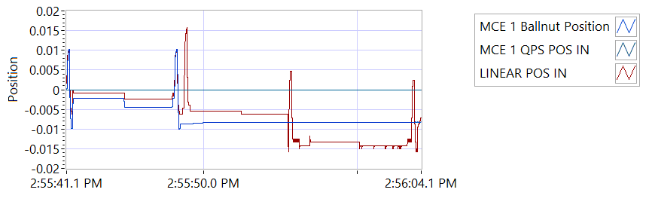

Figure -Hold Brake ON for MCE 1

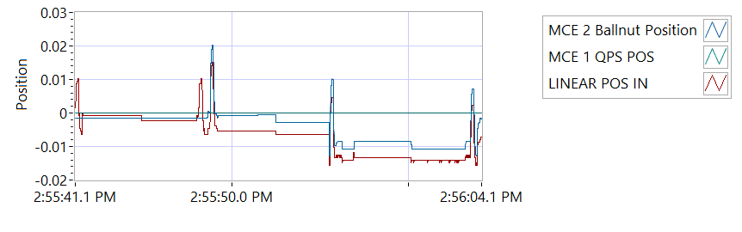

Figure -Hold Brake ON for MCE 2

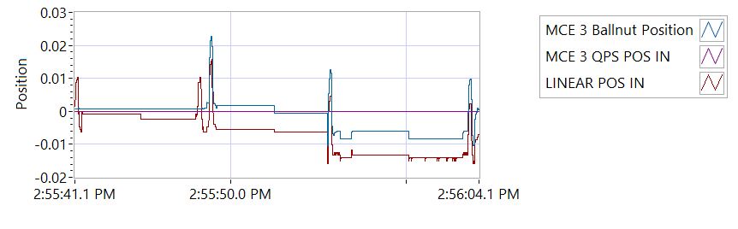

Figure -Hold Brake ON for MCE 3

|  |  |  |  |  |  |  |
| --- | --- | --- | --- | --- | --- | --- |
| **Holding Load Test - Brake ON, LEMA Output Free**  **12.6 +/- 8 Amps for 3-5 seconds** | | | | | | |
| **Requirements** | **Results** | | | | | |
| **MCE** | **MCE Current** | **Units** | **Current Pass/Fail** | **Position feedback** | **Units** | **Position Feedback Pass/Fail** |
| MCE 1, 6.6.3.2.1 step I – extend 0.4 in | 6.0002 | A | Pass | -0.0008 | in | Pass |
| MCE 1, 6.6.3.2.1 step k - retract 0.4 in | -5.9882 | A | True | -0.0024 | in | Pass |
| MCE 2, 6.6.3.2.2 step i – extend 0.4 in | 6.0064 | A | True | -0.0055 | in | Pass |
| MCE 2, 6.6.3.2.2 step k - retract 0.4 in | -5.9905 | A | True | -0.0063 | in | Pass |
| MCE 3, 6.6.3.2.3 step I – extend 0.4 in | 5.991 | A | True | -0.0134 | in | Pass |
| MCE 3, 6.6.3.2.3 step k - retract 0.4 in | -5.9951 | A | True | -0.0142 | in | Pass |

**6.6.4 Brake Release Test**

|  |  |  |  |  |  |
| --- | --- | --- | --- | --- | --- |
| **Brake Release Test** | | | | | |
| **Requirements** | | | **Results** | | |
| Description | Expected | Tolerance | Position | Units | Pass/Fail |
| MCE1 /Motor 1 | 0.4 | 0.05 | 0.400 | in | Pass |
| MCE2 /Motor 2 | 0.4 | 0.05 | 0.400 | in | Pass |
| MCE3 /Motor 3 | 0.4 | 0.05 | 0.400 | in | Pass |

**6.6.5 N1 and N2 Extend Mechanical Stops and MCE Rigging**

|  |  |  |  |
| --- | --- | --- | --- |
| **Extend using M1/N1** | | | |
| **Requirements** | **Results** | | |
| **Description** | **Value** | **Units** | **Pass/Fail** |
| N1 extend stop engaged (M1 current saturated) | 1024 | Code | Pass |
| MCE 1 Motor Current 4.5 +/- 0.15 Amps | 5.9836 | A | Failed |
| Linear Encoder Value | 0.0693 | in | Pass |
| N1 is Rigged | 0 | Code | Pass |

|  |  |  |  |
| --- | --- | --- | --- |
| **Extend using M2/N2** | | | |
| **Requirements** | **Results** | | |
| **Description** | **Value** | **Units** | **Pass/Fail** |
| N2 extend stop engaged (M2 current saturated) | 1024 | Code | Pass |
| MCE2 Motor Current 4.5 +/- 0.15 Amps | 6.0061 | A | Failed |
| Linear Encoder Value | 0.0228 | in | Pass |
| N2 (Motor 2) is Rigged | 0 | Code | Pass |
| N2 (Motor 3) is Rigged | 0 | Code | Pass |

**6.6.6 N1 and N2 Stroke Check**

|  |  |  |  |  |  |
| --- | --- | --- | --- | --- | --- |
| **N1 and N2 Stroke Check Position** | | | | | |
| **Requirements** | | | **Results** | | |
| **Pin to pin Length** | **Expected** | **Tolerance** | **Pin to Pin Length** | **Units** | **Pass/Fail** |
| 16.7445 | 0.0845 | 16.3 | in | Failed |
| **Requirements** | | | **Results** | | |
| **Description** | **Expected** | **Tolerance** | **Actual Position N1/N2** |  | **Pass/Fail** |
| N2 at -0.575 ins from Null using M2 | -0.575 | 0.1 | -0.575 | in | Pass |
| N1 at +1.725 ins from Null using M1 | 1.725 | 0.1 | 1.7249 | in | Pass |
| N1 at -0.575 ins from Null using M1 | -0.575 | 0.1 | -0.575 | in | Pass |
| N2 at +1.725 ins from NULL using M2 | 1.725 | 0.1 | 1.725 | in | Pass |
| N1 at -0.575 ins from Null using M1 | -0.575 | 0.1 | -0.575 | in | Pass |
| N2 at +1.725 ins from Null using M3 | 1.725 | 0.1 | 1.7241 | in | Pass |
| N2 at -0.575 ins from Null using M3 | -0.575 | 0.1 | -0.5735 | in | Pass |

|  |  |  |  |  |  |
| --- | --- | --- | --- | --- | --- |
| **All Motor Stroke Check Description** | | | | | |
| **Requirements** | | | **Results** | | |
| **Description** | **Expected Difference from Test rig encoder** | **Tolerance** | **Difference from Test rig encoder** | **Units** | **Pass/Fail** |
| Motor 1 position + Motor 2 position = test rig encoder | 0 | 0.1 | 0.0108 | in | Pass |
| Motor1 position + Motor 3 position = test rig encoder | 0 | 0.1 | 0.0108 | in | Pass |
| M1 position + M2 position = test rig encoder | 0.1 | 0.1 | -0.3647 | in | Failed |
| M1 position + M3 position = test rig encoder | 0 | 0.1 | -0.3647 | in | Failed |
| Difference between Motor 2 position and Motor 3 position is < TBD ins | 0 | 0.1 | 0 | in | Pass |
| Difference between M2 position and M3 position is < TBD ins | 0 | 0 | 0 | in | Pass |
| Difference between Motor 1 position and M1 position is < TBD ins | 0 | 0.1 | 0.9505 | in | Failed |
| Difference between Motor 2 position and M2 position is < TBD ins | 0 | 0.1 | 0.575 | in | Failed |
| Difference between Motor 3 position and M3 position is < TBD ins | 0 | 0.1 | 0.575 | in | Failed |

MOTOR 1

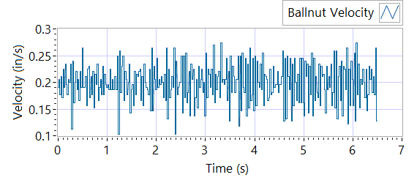

Figure - Ballnut Velocity for Motor One

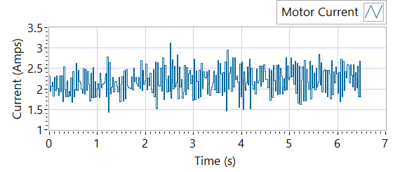

Figure -Current for Motor One

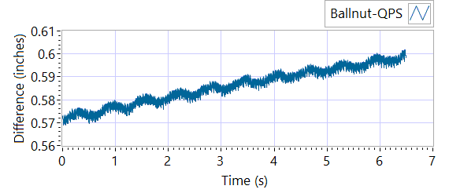

Figure - M1 Delta for Motor One

|  |  |  |  |  |  |  |
| --- | --- | --- | --- | --- | --- | --- |
| **MOTOR 1 STROKE CHECK** | | | | | | |
| **Requirements** | | | **Results** | | | |
| **Description** | **Expected** | **Tolerance** | **Actual Average** | **Peak Velocity** | **Units** | **Pass/Fail** |
| Constant Velocity | 0.2 | 0.02 | 0.1993 | 0.1993 | in/s | Pass |
| **Description** | **Expected** | **Tolerance** | **Actual** | **Standard Deviation** | **Units** | **Pass/Fail** |
| Delta between Motor 1 Position and M1 position | 0.1 | 0.2 | 1.598 | 0.0079 | in | Failed |
| Delta between Motor 1 Position and Linear Encoder position | 0.1 | 0.2 | 0.6016 | 0.3748 | in | Failed |
| Motor Current |  |  | 2.1954 | 0.3244 | A |  |

MOTOR 2

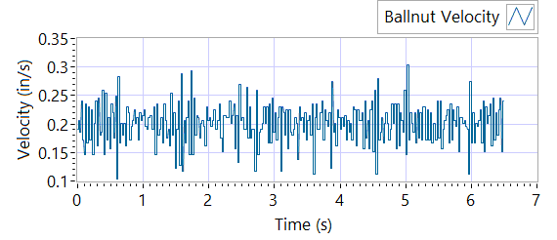

Figure - Ballnut Velocity for Motor Two

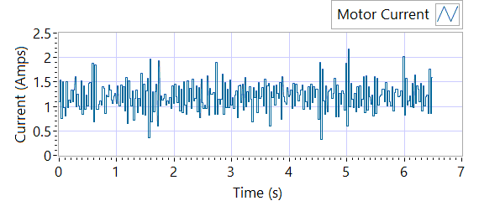

Figure -Current for Motor Two

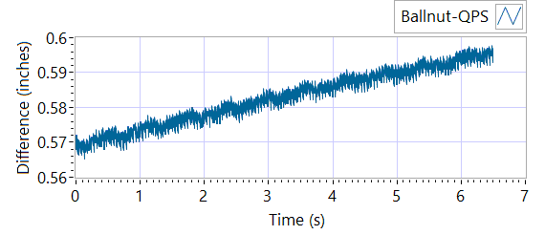

Figure - M1 Delta for Motor Two

|  |  |  |  |  |  |  |
| --- | --- | --- | --- | --- | --- | --- |
| **MOTOR 2 STROKE CHECK** | | | | | | |
| **Requirements** | | | **Results** | | | |
| **Description** | **Expected** | **Tolerance** | **Actual Average** | **Peak Velocity** | **Units** | **Pass/Fail** |
| Constant Velocity | 0.2 | 0.02 | 0.2003 | 0.2003 | in/s | Pass |
| **Description** | **Expected** | **Tolerance** | **Actual** | **Standard Deviation** | **Units** | **Pass/Fail** |
| Delta between Motor 2 Position and M2 position | 0.1 | 0.2 | 1.5963 | 0.0078 | in | Failed |
| Delta between Motor 2 Position and Linear Encoder position | 0.1 | 0.2 | 0.5984 | 0.3748 | in | Failed |
| Motor Current |  |  | 1.2012 | 0.2857 | A |  |

MOTOR 3

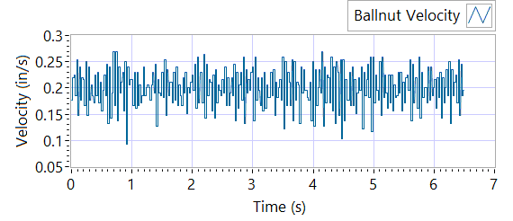

Figure - Ballnut Velocity for Motor Three

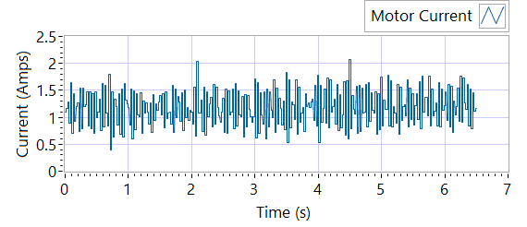

Figure -Current for Motor Three



Figure - M3 Delta for Motor Three

|  |  |  |  |  |  |  |
| --- | --- | --- | --- | --- | --- | --- |
| **MOTOR 3 STROKE CHECK** | | | | | | |
| **Requirements** | | | **Results** | | | |
| **Description** | **Expected** | **Tolerance** | **Actual Average** | **Peak Velocity** | **Units** | **Pass/Fail** |
| Constant Velocity | 0.2 | 0.02 | 0.1995 | 0.1995 | in/s | Pass |
| **Description** | **Expected** | **Tolerance** | **Actual** | **Standard Deviation** | **Units** | **Pass/Fail** |
| Delta between Motor 3 Position and M3 position | 0.1 | 0.2 | 1.5895 | 0.0079 | in | Failed |
| Delta between Motor 3 Position and Linear Encoder position | 0.1 | 0.2 | 0.5977 | 0.3753 | in | Failed |
| Motor Current |  |  | 1.1757 | 0.3353 | A |  |

**6.6.7 Performance Test – unloaded operation (one channel operation)**

**6.6.7.1.1 MCE 1 - Step Response Test**

**The result for motor one is shown below:**

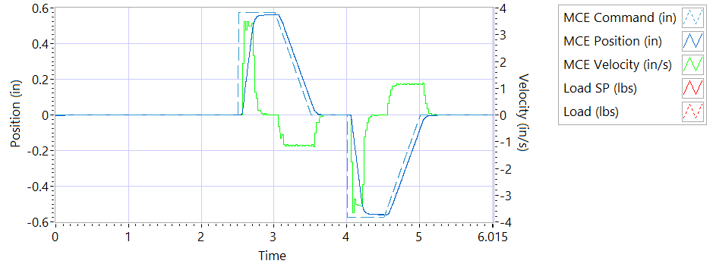

Figure - Results for Motor One

**Step d Extension**

|  |  |  |  |
| --- | --- | --- | --- |
| **MCE 1 - Step Response Extension Unloaded** | | | |
| **Requirements** | **Results** | | |
| **Description** | **Actual Speed / Time** | **Units** | **Pass/Fail** |
| No Load speed is 2.7 to 3.3 in/sec | 3.2653 | in/s | True |
| Time to achieve 80% of the specified stroke (+ 0.575 ins) is 170+9/-9 ms | 0.2097 | seconds | Failed |

**Step e Retraction**

|  |  |  |  |
| --- | --- | --- | --- |
| **MCE 1 - Step Response Retraction Unloaded** | | | |
| **Requirements** | **Results** | | |
| **Description** | **Actual Speed / Time** | **Units** | **Pass/Fail** |
| No Load speed is 2.7 to 3.3 in/sec | -3.259 | in/s | True |
| Time to achieve 80% of the specified stroke (- 0.575 ins) is 170+9/-9 ms | 0.2094 | seconds | Failed |

**6.6.7.1.2 MCE 1 - Frequency Response**

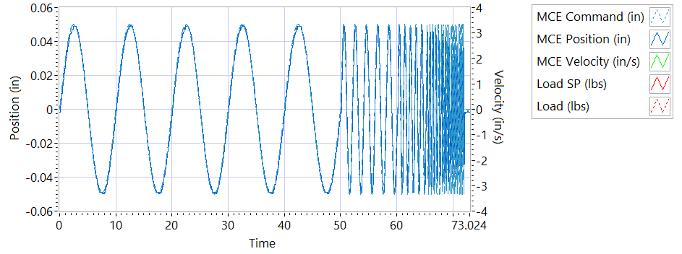

Figure - Phase for Motor One

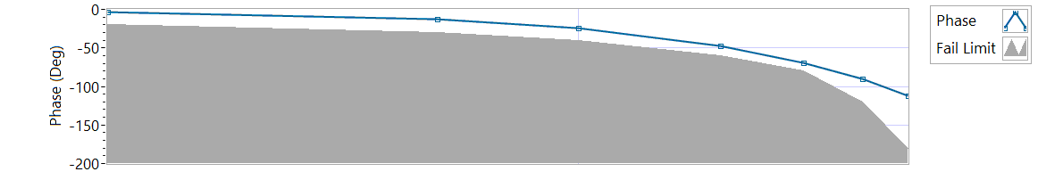

Figure - Phase for Motor One

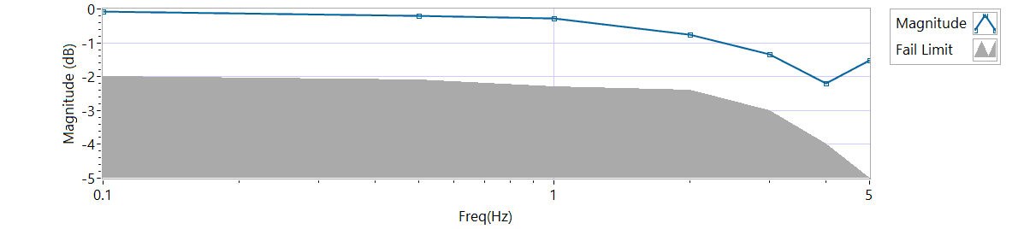

Figure - Magnitude for Motor One

**Frequency Response**

|  |  |  |  |  |
| --- | --- | --- | --- | --- |
| **MCE 1 - Frequency Response Unloaded** | | | | |
| **Frequency**  **(Hz)** | **Magnitude**  **(dB)** | **Phase**  **(deg)** | **Max Phase**  **Allowance (deg)** | **Pass/Fail** |
| 0.1 Hz | -0.0868914 | -3.0096 | -20 | Pass |
| 0.5 Hz | -0.212072 | -12.762 | -30 | Pass |
| 1 Hz | -0.282405 | -24.192 | -40 | Pass |
| 2 Hz | -0.761445 | -46.944 | -60 | Pass |
| 3 Hz | -1.34783 | -69.768 | -80 | Pass |
| 4 Hz | -2.20461 | -90.288 | -120 | Pass |
| 5 Hz | -1.52034 | -111.6 | -180 | Pass |

6.6.7.2.1 **MCE 2 - Step Response Test**

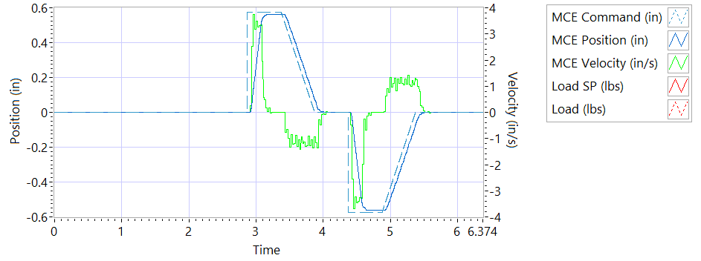

Figure - Results for Motor Two

**Step d Extension**

|  |  |  |  |
| --- | --- | --- | --- |
| **MCE 2 - Step Response Extension Unloaded** | | | |
| **Requirements** | **Results** | | |
| **Description** | **Actual Speed / Time** | **Units** | **Pass/Fail** |
| No Load speed is 2.7 to 3.3 in/sec | 3.2712 | in/s | Pass |
| Time to achieve 80% of the specified stroke (+ 0.575 ins) is 170+9/-9 ms | 0.2111 | seconds | Failed |

**Step e Retraction**

|  |  |  |  |
| --- | --- | --- | --- |
| **MCE 2 - Step Response Retraction Unloaded** | | | |
| **Requirements** | **Results** | | |
| **Description** | **Actual Speed / Time** | **Units** | **Pass/Fail** |
| No Load speed is 2.7 to 3.3 in/sec | -3.265 | in/s | Pass |
| Time to achieve 80% of the specified stroke (- 0.575 ins) is 170+9/-9 ms | 0.2075 | seconds | Failed |

6.6.7.2.2 **MCE 2 - Frequency Response Test**

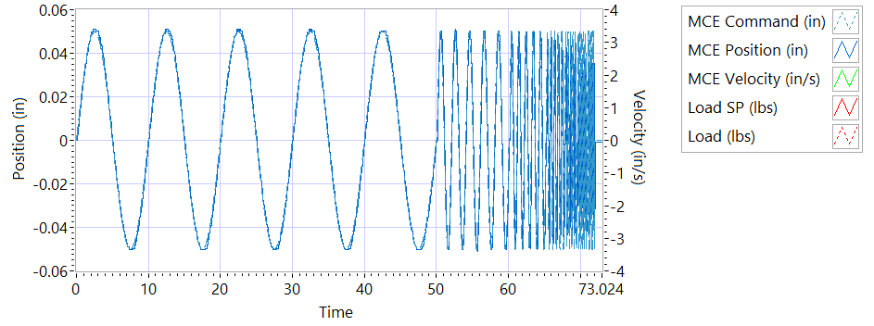

Figure - Phase for Motor One

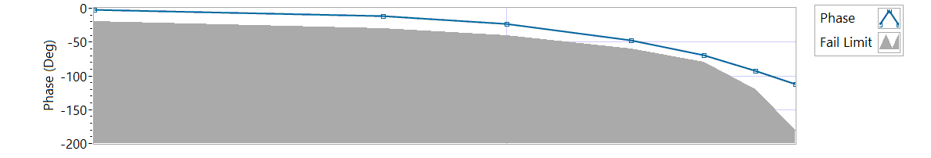

Figure - Phase for Motor Two

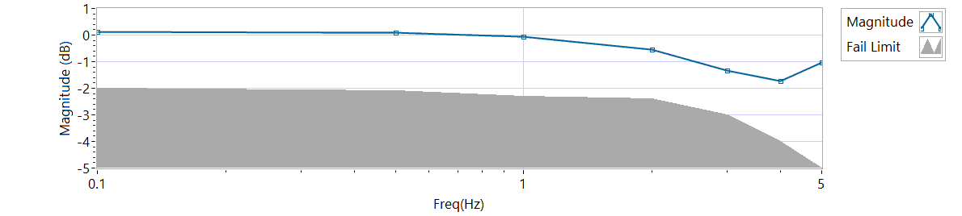

Figure - Magnitude for Motor Two

**Frequency Response**

|  |  |  |  |  |
| --- | --- | --- | --- | --- |
| **MCE 2 - Frequency Response Unloaded** | | | | |
| **Frequency (Hz)** | **Magnitude**  **(dB)** | **Phase**  **(Deg)** | **Max Phase**  **Allowance (Deg)** | **Pass/Fail** |
| 0.1 Hz | 0.117812 | -2.214 | -20 | Pass |
| 0.5 Hz | 0.0907945 | -11.394 | -30 | Pass |
| 1 Hz | -0.0730935 | -23.256 | -40 | Pass |
| 2 Hz | -0.540418 | -46.872 | -60 | Pass |
| 3 Hz | -1.33188 | -69.228 | -80 | Pass |
| 4 Hz | -1.73928 | -92.016 | -120 | Pass |
| 5 Hz | -1.04446 | -112.5 | -180 | Pass |

6.6.7.3.1 **MCE 3 – Step Response Test**

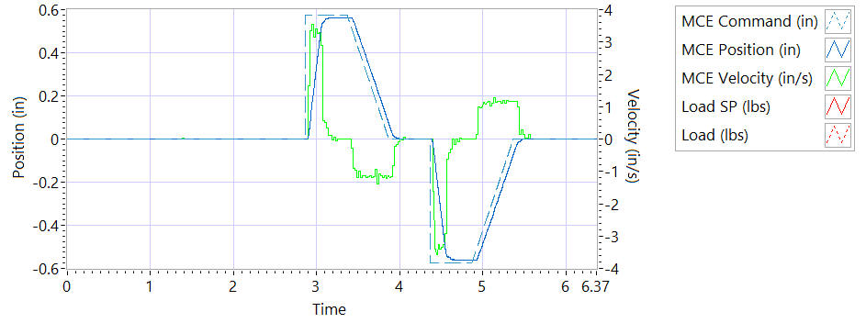

Figure - Results for Motor Three

**Step d Extension**

|  |  |  |  |
| --- | --- | --- | --- |
| **MCE 3 – Step Response Extension Unloaded** | | | |
| **Requirements** | **Results** | | |
| **Description** | **Actual Speed / Time** | **Units** | **Pass/Fail** |
| No Load speed is 2.7 to 3.3 in/sec | 3.2685 | in/s | Pass |
| Time to achieve 80% of the specified stroke (+ 0.575 ins) is 170+9/-9 ms | 0.1929 | seconds | Failed |

**Step e Retraction**

|  |  |  |  |
| --- | --- | --- | --- |
| **MCE 3 – Step Response Retraction Unloaded** | | | |
| **Requirements** | **Results** | | |
| **Description** | **Actual Speed / Time** | **Units** | **Pass/Fail** |
| No Load speed is 2.7 to 3.3 in/sec | -3.276 | in/s | Pass |
| Time to achieve 80% of the specified stroke (- 0.575 ins) is 170+9/-9 ms | 0.1893 | seconds | Failed |

6.6.7.3.2 **MCE 3 Frequency Response Test**

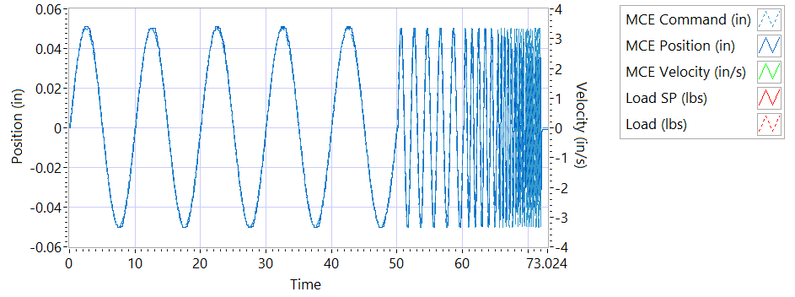

Figure - Phase for Motor One

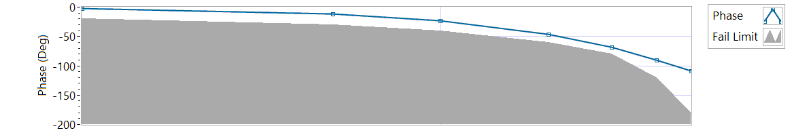

Figure - Phase for Motor Three

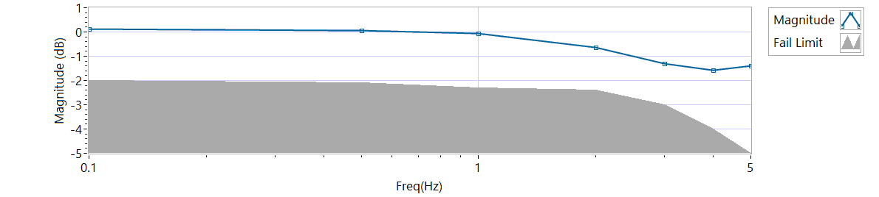

Figure - Magnitude for Motor Three

|  |  |  |  |  |
| --- | --- | --- | --- | --- |
| **MCE 3 Frequency Response Unloaded** | | | | |
| **Frequency**  **(Hz)** | **Magnitude**  **(dB)** | **Phase**  **(Deg)** | **Max Phase**  **Allowance (Deg)** | **Pass/Fail** |
| 0.1 Hz | 0.117812 | -2.2068 | -20 | Pass |
| 0.5 Hz | 0.0636932 | -11.556 | -30 | Pass |
| 1 Hz | -0.0455633 | -22.968 | -40 | Pass |
| 2 Hz | -0.628156 | -46.44 | -60 | Pass |
| 3 Hz | -1.31595 | -68.364 | -80 | Pass |
| 4 Hz | -1.57901 | -90.72 | -120 | Pass |
| 5 Hz | -1.38479 | -109.08 | -180 | Pass |

**6.6.8 Performance Test – Loaded Operation**

**6.6.8.1.1 MCE1 – Step Response Test**

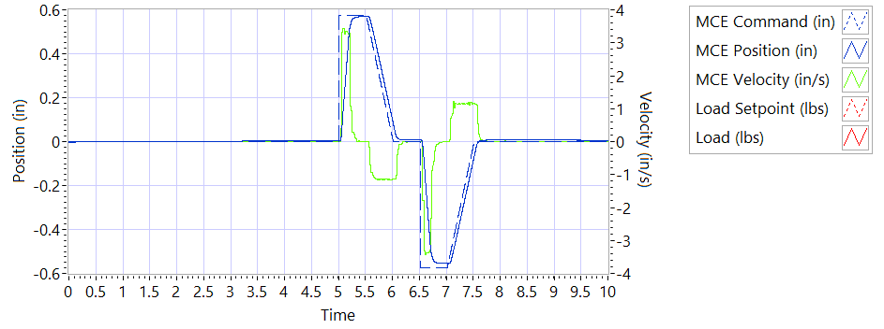

Figure - Results for Motor One Loaded

Step response Test

**225 lbf tension - Extension**

|  |  |  |  |
| --- | --- | --- | --- |
| **MCE1 – Step Response Tension Extension** | | | |
| **Requirements** | **Results** | | |
| **Description** | **Actual Speed / Time** | **Units** | **Pass/Fail** |
| No Load speed is 2.7 to 3.3 in/sec | 3.2369 | in/s | Pass |
| Time to achieve 80% of the specified stroke (+ 0.575 ins) is 170+9/-9 ms | 0.1945 | seconds | Failed |

**225 lbf tension - Retraction**

|  |  |  |  |
| --- | --- | --- | --- |
| **MCE1 – Step Response Tension Retraction** | | | |
| **Requirements** | **Results** | | |
| **Description** | **Actual Speed / Time** | **Units** | **Pass/Fail** |
| No Load speed is 2.7 to 3.3 in/sec | -3.2787 | in/s | Pass |
| Time to achieve 80% of the specified stroke (- 0.575 ins) is 170+9/-9 ms | 0.2033 | seconds | Failed |

**225 lbf compression - Extension**

|  |  |  |  |
| --- | --- | --- | --- |
| **MCE1 – Step Response Compression Extension** | | | |
| **Requirements** | **Results** | | |
| **Description** | **Actual Speed / Time** | **Units** | **Pass/Fail** |
| No Load speed is 2.7 to 3.3 in/sec | 3.3315 | in/s | Pass |
| Time to achieve 80% of the specified stroke (+0.575 ins) is 170+9/-9 ms | 0.1959 | seconds | Failed |

**225 lbf compression - Retraction**

|  |  |  |  |
| --- | --- | --- | --- |
| **MCE1 – Step Response Compression Retraction** | | | |
| **Requirements** | **Results** | | |
| **Description** | **Actual Speed / Time** | **Units** | **Pass/Fail** |
| No Load speed is 2.7 to 3.3 in/sec | -3.2257 | in/s | Pass |
| Time to achieve 80% of the specified stroke (-0.575 ins) is 170+9/-9 ms | 0.1833 | seconds | Failed |

**6.6.8.1.2 MCE 1 – Frequency Response Test**

**225 lbf Tension**

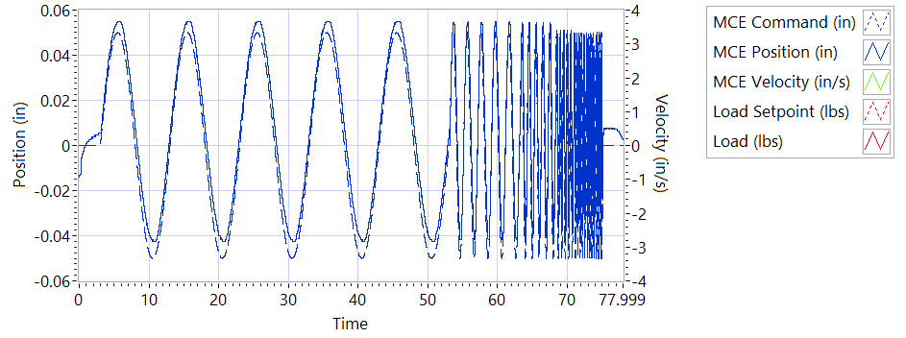

Figure - Frequency for Motor One Loaded Tension

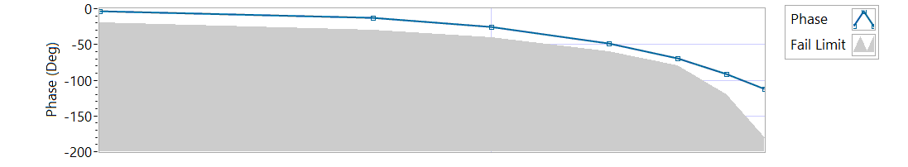

Figure - Phase for Motor One Loaded Tension

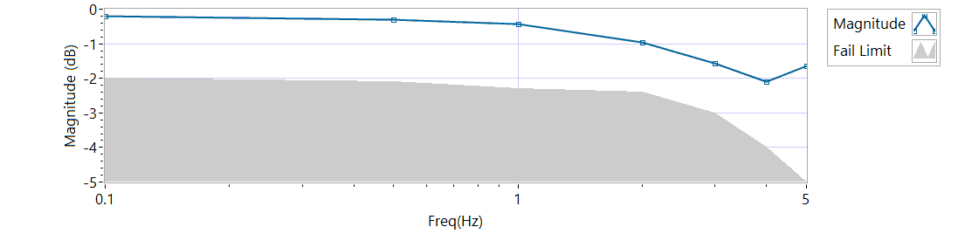

Figure - Magnitude for Motor One Loaded Tension

|  |  |  |  |  |
| --- | --- | --- | --- | --- |
| **MCE 1 – Tension Frequency Response** | | | | |
| **Frequency**  **(Hz)** | **Magnitude**  **(dB)** | **Phase**  **(Deg)** | **Max Phase**  **Allowance (Deg)** | **Pass/Fail** |
| 0.1 HZ | -0.212072 | -3.0024 | -20 | Pass |
| 0.5 HZ | -0.310697 | -12.654 | -30 | Pass |
| 1 HZ | -0.424798 | -25.128 | -40 | Pass |
| 2 HZ | -0.957659 | -48.96 | -60 | Pass |
| 3 HZ | -1.57429 | -69.876 | -80 | Pass |
| 4 HZ | -2.09872 | -90.864 | -120 | Pass |
| 5 HZ | -1.65291 | -112.5 | -180 | Pass |

**225 lbf Compression**

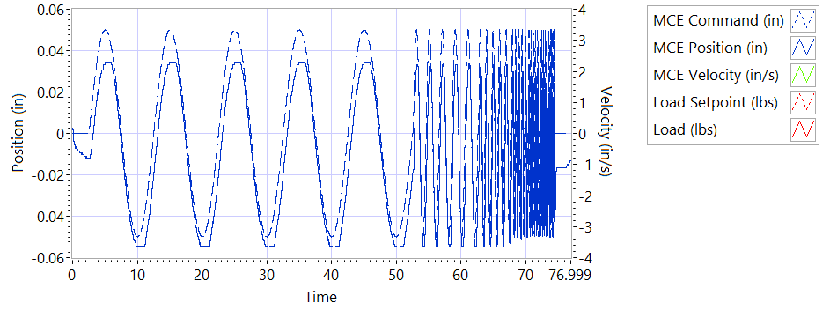

Figure - Frequency for Motor One Loaded Compression

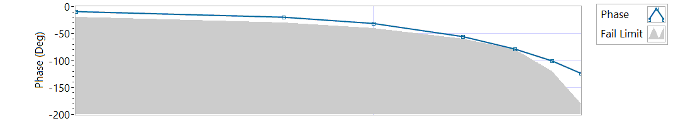

Figure - Phase for Motor One Loaded Compression

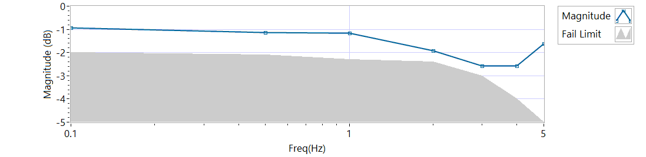

Figure - Magnitude for Motor One Loaded Compression

|  |  |  |  |  |
| --- | --- | --- | --- | --- |
| **MCE 1 – Compression Frequency Response** | | | | |
| **Frequency**  **(Hz)** | **Magnitude**  **(dB)** | **Phase**  **(Deg)** | **Max Phase**  **Allowance (Deg)** | **Pass/Fail** |
| 0.1 HZ | -0.942407 | -8.8128 | -20 | Pass |
| 0.5 HZ | -1.12722 | -19.566 | -30 | Pass |
| 1 HZ | -1.17404 | -31.572 | -40 | Pass |
| 2 HZ | -1.92555 | -55.656 | -60 | Pass |
| 3 HZ | -2.5744 | -78.732 | -80 | Pass |
| 4 HZ | -2.57555 | -100.944 | -120 | Pass |
| 5 HZ | -1.62253 | -123.66 | -180 | Pass |

**6.6.8.2.1 MCE 2 – Step Response Test**

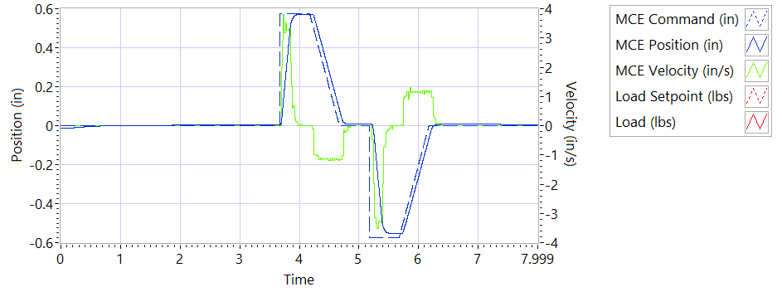

Figure - Results for Motor Two Loaded Tension

**225 lbf tension - Extension**

|  |  |  |  |
| --- | --- | --- | --- |
| **MCE2 – Step Response Tension Extension** | | | |
| **Requirements** | **Results** | | |
| **Description** | **Actual Speed / Time** | **Units** | **Pass/Fail** |
| No Load speed is 2.7 to 3.3 in/sec | 3.254 | in/s | Pass |
| Time to achieve 80% of the specified stroke (+ 0.575 ins) is 170+9/-9 ms | 0.1877 | seconds | Failed |

**225 lbf tension - Retraction**

|  |  |  |  |
| --- | --- | --- | --- |
| **MCE2 – Step Response Tension Retraction** | | | |
| **Requirements** | **Results** | | |
| **Description** | **Actual Speed / Time** | **Units** | **Pass/Fail** |
| No Load speed is 2.7 to 3.3 in/sec | -3.3121 | in/s | Pass |
| Time to achieve 80% of the specified stroke (- 0.575 ins) is 170+9/-9 ms | 0.2259 | seconds | Failed |

**225 lbf compression - Extension**

|  |  |  |  |
| --- | --- | --- | --- |
| **MCE2 – Step Response Compression Extension** | | | |
| **Requirements** | **Results** | | |
| **Description** | **Actual Speed / Time** | **Units** | **Pass/Fail** |
| No Load speed is 2.7 to 3.3 in/sec | 3.3011 | in/s | Pass |
| Time to achieve 80% of the specified stroke (+0.575 ins) is 170+9/-9 ms | 0.2236 | seconds | Failed |

**225 lbf compression - Retraction**

|  |  |  |  |
| --- | --- | --- | --- |
| **MCE2 – Step Response Compression Retraction** | | | |
| **Requirements** | **Results** | | |
| **Description** | **Actual Speed / Time** | **Units** | **Pass/Fail** |
| No Load speed is 2.7 to 3.3 in/sec | -3.2464 | in/s | Pass |
| Time to achieve 80% of the specified stroke (-0.575 ins) is 170+9/-9 ms | 0.2146 | seconds | Failed |

**6.6.8.2.2 MCE 2 – Frequency response Test**

**225 lbf Tension**

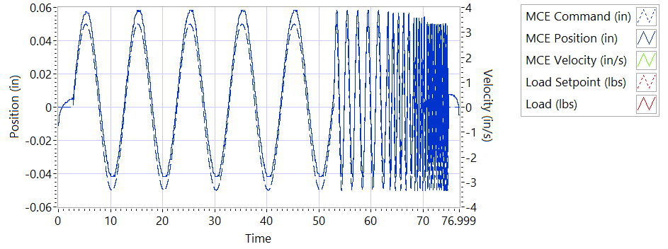

Figure - Frequency for Motor Two Loaded Tension

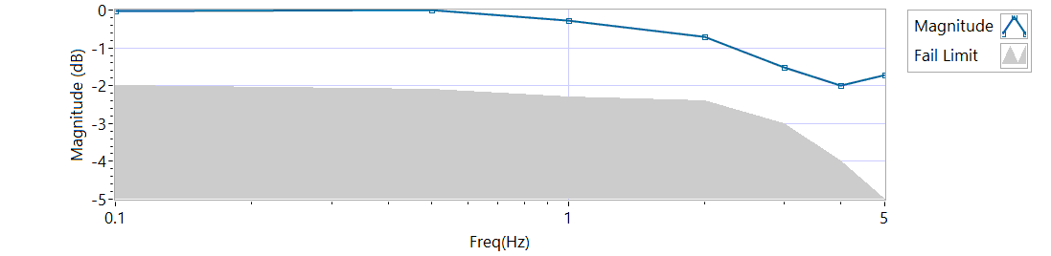

Figure - Magnitude for Motor Two Loaded Tension

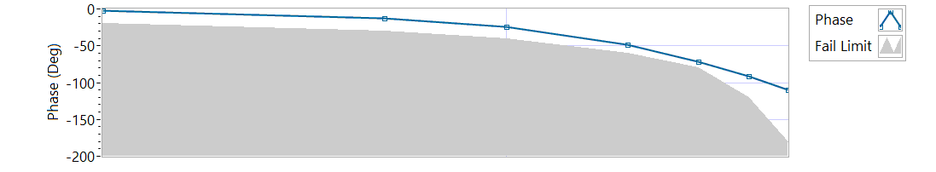

Figure - Phase for Motor Two Loaded Tension

|  |  |  |  |  |
| --- | --- | --- | --- | --- |
| **MCE 2 – Frequency response Tension** | | | | |
| **Frequency**  **(Hz)** | **Magnitude**  **(dB)** | **Phase**  **(Deg)** | **Max Phase**  **Allowance (Deg)** | **Pass/Fail** |
| 0.1 HZ | -0.0181206 | -2.3184 | -20 | Pass |
| 0.5 HZ | -0.00443087 | -12.276 | -30 | Pass |
| 1 HZ | -0.26829 | -24.66 | -40 | Pass |
| 2 HZ | -0.701952 | -48.096 | -60 | Pass |
| 3 HZ | -1.52526 | -71.172 | -80 | Pass |
| 4 HZ | -2.00727 | -91.008 | -120 | Pass |
| 5 HZ | -1.72596 | -109.62 | -180 | Pass |

**225 lbf Compression**

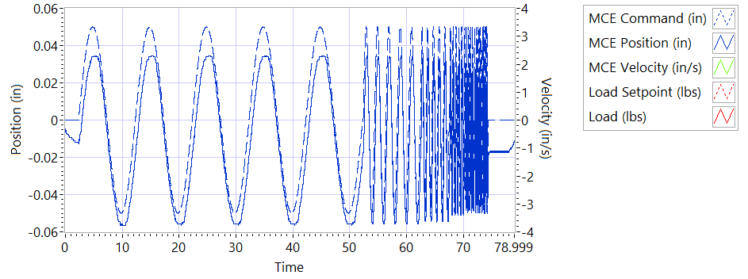

Figure - Frequency for Motor One Loaded Compression

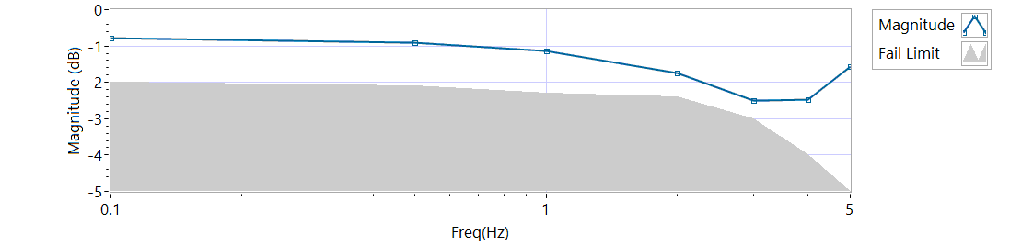

Figure - Magnitude for Motor Two Loaded Compression

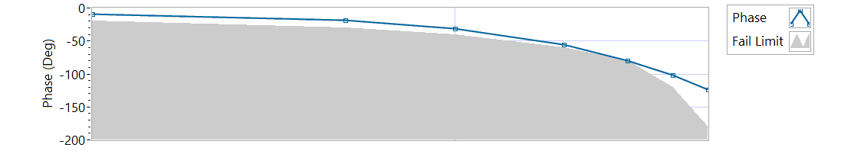

Figure - Phase for Motor Two Loaded Compression

|  |  |  |  |  |
| --- | --- | --- | --- | --- |
| **MCE 2 – Frequency response Compression** | | | | |
| **Frequency**  **(Hz)** | **Magnitude**  **(dB)** | **Phase**  **(Deg)** | **Max Phase**  **Allowance (Deg)** | **Pass/Fail** |
| 0.1 HZ | -0.791343 | -8.7624 | -20 | Pass |
| 0.5 HZ | -0.911986 | -19.026 | -30 | Pass |
| 1 HZ | -1.1428 | -31.32 | -40 | Pass |
| 2 HZ | -1.73984 | -55.656 | -60 | Pass |
| 3 HZ | -2.50195 | -79.596 | -80 | Pass |
| 4 HZ | -2.47968 | -102.24 | -120 | Pass |
| 5 HZ | -1.55385 | -123.3 | -180 | Pass |

**6.6.8.3.1 MCE 3 – Step Response Test**

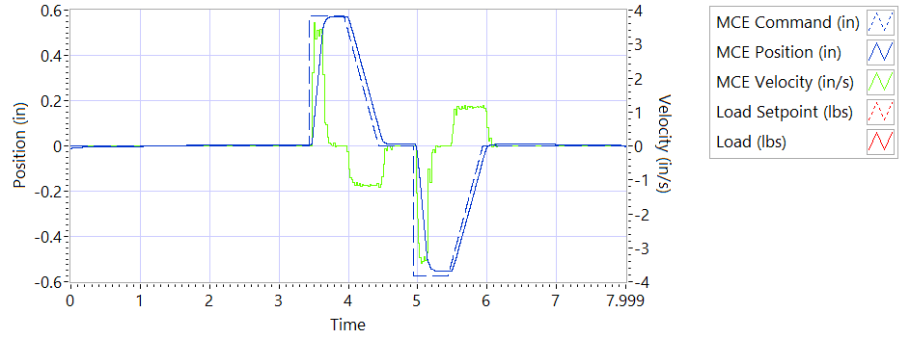

Figure - Results for Motor Three

**225 lbf tension - Extension**

|  |  |  |  |
| --- | --- | --- | --- |
| **MCE3 – Step Response Tension Extension** | | | |
| **Requirements** | **Results** | | |
| **Description** | **Actual Speed / Time** | **Units** | **Pass/Fail** |
| No Load speed is 2.7 to 3.3 in/sec | 3.2558 | in/s | Pass |
| Time to achieve 80% of the specified stroke (+ 0.575 ins) is 170+9/-9 ms | 0.2038 | seconds | Failed |

**225 lbf tension - Retraction**

|  |  |  |  |
| --- | --- | --- | --- |
| **MCE3 – Step Response Tension Retraction** | | | |
| **Requirements** | **Results** | | |
| **Description** | **Actual Speed / Time** | **Units** | **Pass/Fail** |
| No Load speed is 2.7 to 3.3 in/sec | -3.3179 | in/s | Pass |
| Time to achieve 80% of the specified stroke (- 0.575 ins) is 170+9/-9 ms | 0.2097 | seconds | Failed |

**225 lbf compression - Extension**

|  |  |  |  |
| --- | --- | --- | --- |
| **MCE3 – Step Response Compression Extension** | | | |
| **Requirements** | **Results** | | |
| **Description** | **Actual Speed / Time** | **Units** | **Pass/Fail** |
| No Load speed is 2.7 to 3.3 in/sec | 3.313 | in/s | Pass |
| Time to achieve 80% of the specified stroke (+0.575 ins) is 170+9/-9 ms | 0.2079 | seconds | Failed |

**225 lbf compression - Retraction**

|  |  |  |  |
| --- | --- | --- | --- |
| **MCE3 – Step Response Compression Retraction** | | | |
| **Requirements** | **Results** | | |
| **Description** | **Actual Speed / Time** | **Units** | **Pass/Fail** |
| No Load speed is 2.7 to 3.3 in/sec | -3.2466 | in/s | Pass |
| Time to achieve 80% of the specified stroke (-0.575 ins) is 170+9/-9 ms | 0.1987 | seconds | Failed |

**6.6.8.3.2 MCE 3 – Frequency Response Test**

**225 lbf Tension**

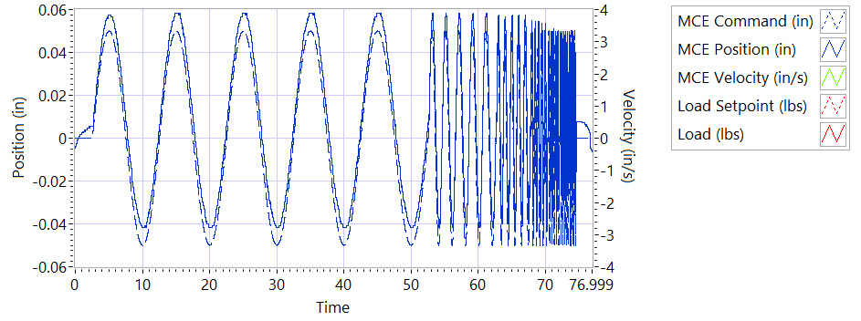

Figure - Frequency for Motor Two Loaded Tension

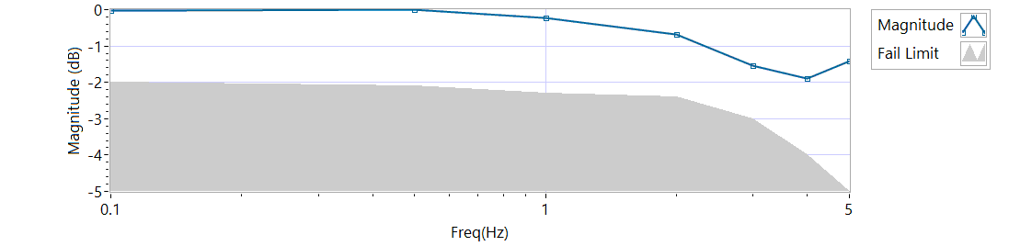

Figure - Magnitude for Motor Three Loaded Tension

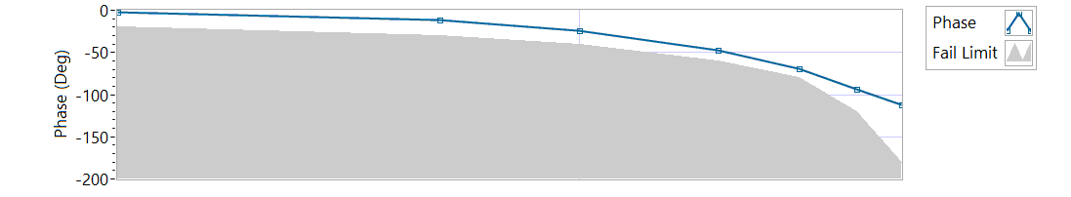

Figure - Phase for Motor Three Loaded Tension

|  |  |  |  |  |
| --- | --- | --- | --- | --- |
| **MCE 3 – Tension Frequency Response** | | | | |
| **Frequency**  **(Hz)** | **Magnitude**  **(dB)** | **Phase**  **(Deg)** | **Max Phase**  **Allowance (Deg)** | **Pass/Fail** |
| 0.1 HZ | -0.0181206 | -2.0232 | -20 | Pass |
| 0.5 HZ | -0.00443087 | -11.664 | -30 | Pass |
| 1 HZ | -0.226092 | -24.048 | -40 | Pass |
| 2 HZ | -0.672358 | -47.016 | -60 | Pass |
| 3 HZ | -1.54158 | -69.876 | -80 | Pass |
| 4 HZ | -1.90026 | -93.456 | -120 | Pass |
| 5 HZ | -1.408 | -111.6 | -180 | Pass |

**225 lbf Compression**



Figure - Frequency for Motor Three Loaded Compression

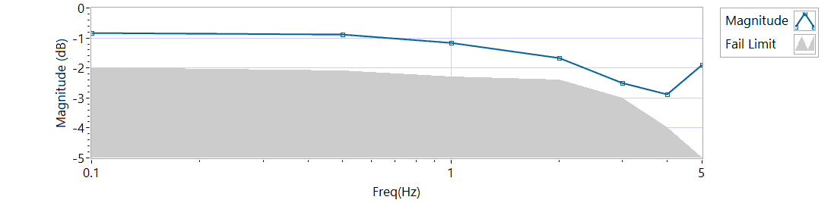

Figure - Magnitude for Motor Three Loaded Compression

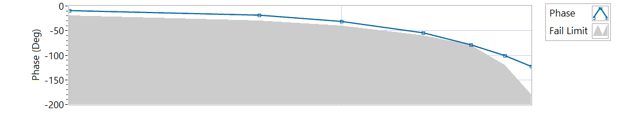

Figure - Phase for Motor Three Loaded Compression

|  |  |  |  |  |
| --- | --- | --- | --- | --- |
| **MCE 3 – Compression Frequency Response** | | | | |
| **Frequency**  **(Hz)** | **Magnitude**  **(dB)** | **Phase**  **(Deg)** | **Max Phase**  **Allowance (Deg)** | **Pass/Fail** |
| 0.1 HZ | -0.821347 | -8.8128 | -20 | Pass |
| 0.5 HZ | -0.881668 | -19.026 | -30 | Pass |
| 1 HZ | -1.17404 | -31.284 | -40 | Pass |
| 2 HZ | -1.65672 | -54.576 | -60 | Pass |
| 3 HZ | -2.48743 | -78.948 | -80 | Pass |
| 4 HZ | -2.88547 | -101.088 | -120 | Pass |
| 5 HZ | -1.8951 | -122.22 | -180 | Pass |

**6.6.9 Backlash**

6.6.9.1 **Simplex Brake 1 – ON; Duplex brake 2 – OFF**

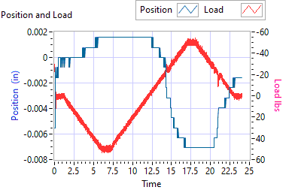

Figure - Backlash Simplex brake 1 On, Duplex brake 2 Off

|  |  |  |  |  |  |
| --- | --- | --- | --- | --- | --- |
| **Simplex Brake 1 – ON; Duplex brake 2 – OFF** | | | | | |
| **Requirements** | | | **Results** | | |
| **Step** | **Expected** | **Tolerance** | **Actual** | **Units** | **Pass/Fail** |
| Step e 35 lbf tension (Motor 2 and Motor 3 zero position) | 0.0144 | 0.005 | 0.0016 | in | Pass |
| 35 | 5 | 49.3431 | lbf | Pass |
| Step e -35 lbf compression (Motor 2 and Motor 3 zero position) | 0.0144 | 0.005 | -0.0071 | in | Pass |
| 35 | 5 | -50.707 | lbf | Pass |

6.6.9.2 **Simplex Brake 1 – OFF; Duplex Brake 2 – ON**

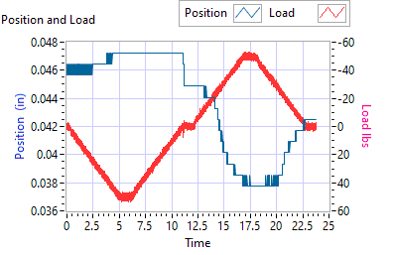

Figure - Backlash Simplex brake 1 Off, Duplex brake 2 On

|  |  |  |  |  |  |
| --- | --- | --- | --- | --- | --- |
| **Simplex Brake 1 – OFF; Duplex Brake 2 – ON** | | | | | |
| **Requirements** | | | **Results** | | |
| **Step** | **Expected** | **Tolerance** | **Actual** | **Units** | **Pass/Fail** |
| Step e 35 lbf tension  (Motor 1 zero position) | 0.0144 | 0.005 | 0.0472 | in | Pass |
| 35 | 5 | 49.7043 | lbf | Pass |
| Step e -35 lbf compression  (Motor 1 zero position) | 0.0144 | 0.005 | 0.0378 | in | Pass |
| -35 | 5 | -49.5757 | lbf | Pass |

6.6.9.3 **Both Brakes OFF**

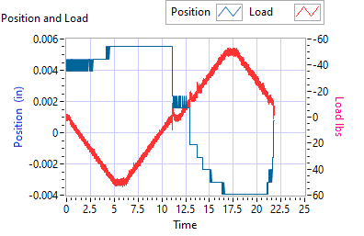

Figure - Backlash Simplex brake 1 Off, Duplex brake 2 Off

|  |  |  |  |  |  |
| --- | --- | --- | --- | --- | --- |
| **Both Brakes OFF** | | | | | |
| **Requirements** | | | **Results** | | |
| **Step** | **Expected** | **Tolerance** | **Actual** | **Units** | **Pass/Fail** |
| Step e 35 lbf tension  (Motor 1 and Motor 2 holding zero position) | 0.0144 | 0.005 | 0.0055 | in | Pass |
| 35 | 5 | 50.0095 | lbf | Pass |
| Step e -35 lbf compression  (Motor 1 and Motor 2 holding zero position) | 0.0144 | 0.005 | -0.0039 | in | Pass |
| -35 | 5 | -49.8032 | lbf | Pass |